**Experiment :9**

**Title:   Write a program in C that creates a child process, waits for the termination of the child and lists its PID.**

**C Program:**

#include<unistd.h>

#include<sys/types.h>

#include<stdio.h>

#include<sys/wait.h>

int main()

{

pid_t p;

printf("Before fork\n");

p=fork();

if(p==0)//child

{

printf("I am child having id %d\n" , getpid());

printf("My parent's id is %d\n" ,getppid());

}

else//parent

{

wait(NULL);

printf("My child's id is %d\n", p );

printf("I am parent having id %d\n", getpid());

}

printf("COMMON\n");

}

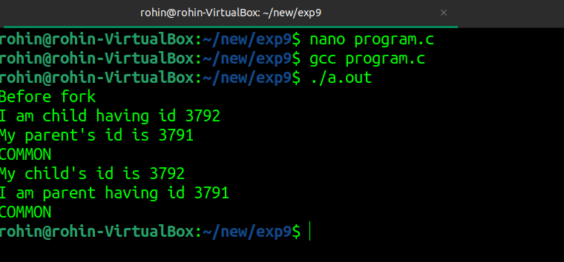**Output:**